A mountain Gorilla
A mountain gorilla went to the dentist,
complaining of toothache.
He opened wide and the dentist sighed,
‘You obviously love your cake!’

The dentist pulled that big bright light,
over the gorilla’s eyes
and leaning over his enormous body,
he tickled his hairy thighs.

The mountain gorilla laughed out loud
and the dentist dropped his drill.
‘This is ridiculous!’ the dentist screamed.
‘You must remain perfectly still!’

The gorilla whispered a secret.
‘I’m terrified of pain.’
‘I appreciate that,’ cried the dentist.
‘But you’re driving me insane!’

The dentist glanced at his fancy watch
and shouted out ‘Oh dear!’
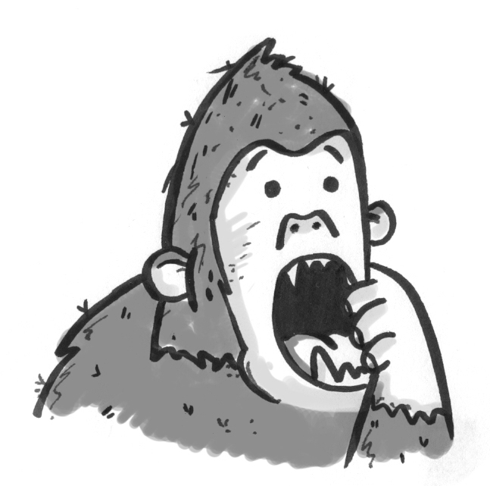
The appointment time of another patient
was drawing dangerously near.

‘I’ll tell him a joke,’ he told his assistant.
‘And when he laughs I’ll pull out his tooth.’
But his master plan was flawed and dangerous
and soon all hell broke loose.

‘Knock! Knock!’ he said. ‘Who’s there?’ asked the gorilla,
so the dentist told his joke.
The gorilla roared with laughter
but punched the light and it broke.

‘Get out of my surgery!’ the dentist screamed.
‘Your tooth’ll fall out on its own!’
But clutching his jaw with a hairy hand,
the gorilla let out a groan.

‘I’ll do it myself!’ he yelled to the dentist.
‘I don’t need your rotten help.’
So he picked up some pliers and extracted his tooth
with a wail and a terrible yelp.

Blood poured out of the gorilla’s mouth
but he was acting tough.
‘Wash your mouth out,’ the dentist cried.
‘Drink some of my pink stuff…’

The gorilla refused and cried out loud:
‘Haven’t you got ‘Coca-Cola’?’
But the dentist frowned and shook his head,
‘it’ll only dissolve your molars.’

‘I’m leaving your surgery!’ the gorilla cried out.
‘This appointment’s a total fiasco!’
So he went straight home and climbed into bed
and put the tooth under his pillow.
www.pauldelaneypoetry.co.uk

