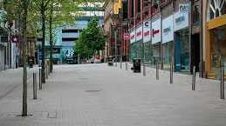
Corona virus rap! May 2020
We’re on the lockdown, we can’t go out.
But the sun’s still shining – what’s that all about?
Life has changed beyond recognition.
And humanity’s searching for an act of contrition.

Prestigious cars not going anywhere.
Their badges irrelevant, a broken love affair.
Empty airports and silent blue skies.
Designer clothes that nobody buys.

And old Mrs Martin’s watching the news,
Listening to experts’ scientific views.
Her son’s a doctor and her daughter’s a nurse,
Fighting 24/7 against this curse.

She’s saying her prayers for the N.H.S.
and essential workers who’re sorting this mess
and innocent victims spread around the earth,
and a better tomorrow, mother nature’s rebirth.

We’re all caged animals, birds with broken wings.
But beginning to appreciate those little things
like family and friends, a hug and a kiss
and life’s simple pleasures, the things we all miss.

Shopping till you’re dropping without complications.
A cheeky gin and tonic at family celebrations.
Watching favourite sports, competing in the park.
meeting friends in the pub, drinking after dark.

I wonder, will life will ever be the same again?

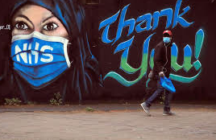
© Paul Delaney May 2020 www.pauldelaneypoetry.co.uk

