‘All the world’s a stage!’ (Diversity poem)

Are all the creatures of the sea the same?
A similar size and colour and name?
Dive into the oceans in a yellow submarine.
And discover a world, an incredible dream.

Green Sea turtles and Royal starfish.
Mythical mermaids, granting a wish.
Turquoise corals, clinging to their reef.
Hammerhead sharks sharpening their teeth.

‘All the world’s a stage!’ said William Shakespeare.
It doesn’t matter how you sound or how you appear.
We’re all very different, just spirits in disguise.
Sharing Mother Earth, like clouds sharing skies.

Rise up above, soaring high in the sky.
Do you dream about birds, their ability to fly?
Not every single bird has the power of flight.
Blackbirds are black and pelicans are white!

A woodpecker, a Hawfinch, and a singing thrush.
A timid tree-creeper seeking solace in a bush.
A hungry golden eagle on her evening prowl.
A swan on her river and a wise old owl.

‘All the world’s a stage!’ said William Shakespeare.
It doesn’t matter how you sound or how you appear.
We’re all very different, just spirits in disguise.
Sharing Mother Earth, like clouds sharing skies.
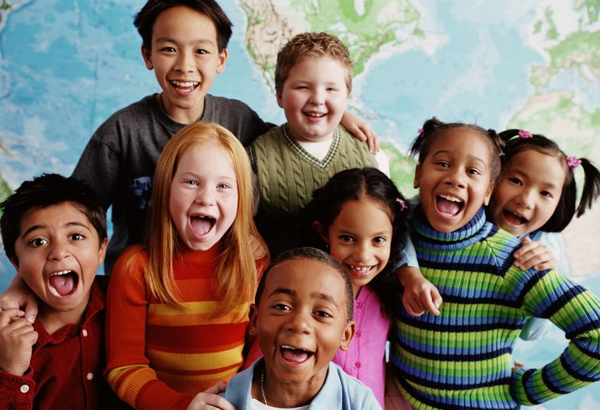

Trek through a rainforest. Those amazing sounds!
Creatures make noises - above, below, around.
Some of them chatter. Some of them grunt.
Some eat plants but most of them hunt.

Marmoset monkeys and cheeky chimpanzees.
Snoozing sloths in tall, emerald trees.
Glass-winged butterlies and tiny tree frogs.
Scarlet Macaws and hungry, hairy hogs!

‘All the world’s a stage!’ said William Shakespeare.
It doesn’t matter how you sound or how you appear.
We’re all very different, just spirits in disguise.
Sharing Mother Earth, like clouds sharing skies.

Walk around a famous city. Look at everybody’s face.
They’re as different as the planets in deep, outer space.
A palette of colours like shoes on a rack.
Enormous variety, the toys in Santa’s sack.

Children from different parts of the world.
Long hair, short hair, straight and curled.
You’re ‘One of a kind’ in your own special way
with your own song to sing and your own words to say.

‘All the world’s a stage!’ said William Shakespeare.
It doesn’t matter how you sound or how you appear.
We’re all very different, just spirits in disguise.
Sharing Mother Earth, like clouds sharing skies.

© Paul Delaney October 2nd 2018 (My mum’s birthday!) www.pauldelaneypoetry.co.uk

For the children of British International School, Budapest

From Paul Delaney’s ‘Get lost!’ poetry book -
Launched at British International School,
Prague, Czech Republic, May 2019

Always remember, there’s NOBODY
like YOU in the whole, wide, world!
An alien spaceship!

An alien spaceship landed on earth,
one cold and windy night.
It crashed in my back garden;
its lights all gold and bright.

‘Are all earthlings just like you?’
asked their leader, his face red and green.
‘I’ll try to explain,’ I answered.
‘I hope you’ll know what I mean…’

My eyes are hot sparklers, all emerald, bright green.
My voice is high-pitched, like a moody teenage Queen.
My skin is brown and smooth, a creamy chocolate bar.
And my legs are as fast as a Lamborghini car.

My hair is countless midnights, long gloss blacks.
My legs are long and thin, high-speed railway tracks.
My lips are wide and full, as thick as a circus clown’s.
And my teeth are as white as diamonds in crowns!

Now go and ask somebody else.

Only then will you find the answer to your question!

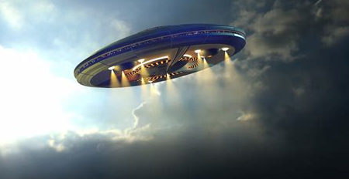

© 2019 Paul Delaney, poem from ‘Get lost! www.pauldelaneypoetry.co.uk
I am a tropical fish!

I am a tropical fish.
I swim in the deep blue sea.
I often wonder, as you do,
What is ‘diversity’?

Turquoise blues and emerald greens.
Shimmering golds and silver sheens.
Carmine reds and purple sapphires.
Orange and yellow, flames in fires.

Countless colours and different sizes.
Magical creations - birthday surprises!
Gold and silver, bronze coloured scales.
Powerful predators and peace-loving whales.

Are humans all different or sort of the same?
Sharing a face whilst sharing a name?
Or is life on land like under the sea?
A miraculous mix of variety?

I think so, don’t you?
And guess what?
We’re all basically the same.
A spirit or a soul, wrapped up inside a body.
And everybody is special and unique.
And so are you.
So always remember that!

Poem © Paul Delaney 2019 from ‘Get lost!’ www.pauldelaneypoetry.co.uk

