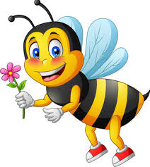
God made you, God made me!

God made you, God made me!
God made the wings on a Bumble Bee,
God made the sun, the moon and the stars
and everything all around me!

God made daylight – be your best!
And magical midnight – time to rest!
Fluffy clouds; wind and rain
and God said ‘I am pleased!’

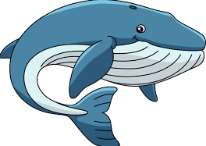
God made you…

God made oceans, lands and seas
and colourful flowers, plants and trees.
Big blue whales and silver fish
and God said ‘I am pleased!’

God made you…

God made mountains, high, high, high!
And beautiful birds, fly, fly, fly!
Insects, animals, big and small
and God said ‘I am pleased!’

God made you…

God made my family, all my friends!
He is amazing; his love never ends!
He carved my name on his hand
and God said ‘I am pleased!’

© Paul Delaney Friday 9th September 2022
www.pauldelaneypoetry.co.uk

Written for St. George’s Catholic Primary School, York, England.

