Grandad Ken

He’s waiting on the playground, my grandad Ken.
He’s hanging around, a King amongst men.

Day after day, he’s right on time,
in all kinds of weather, come rain or shine.

He takes me home and we watch TV,
whilst Nanny’s in the kitchen, cooking our tea.

Three cheers for our grandparents, who turn up at school,
dropping us off and picking us up, now that’s really cool!

Hip, hip! Hooray! (x3)

© 2015 Paul Delaney, from ‘Hedgehogs 1 Big trucks 0’
www.pauldelaneypoetry.co.uk
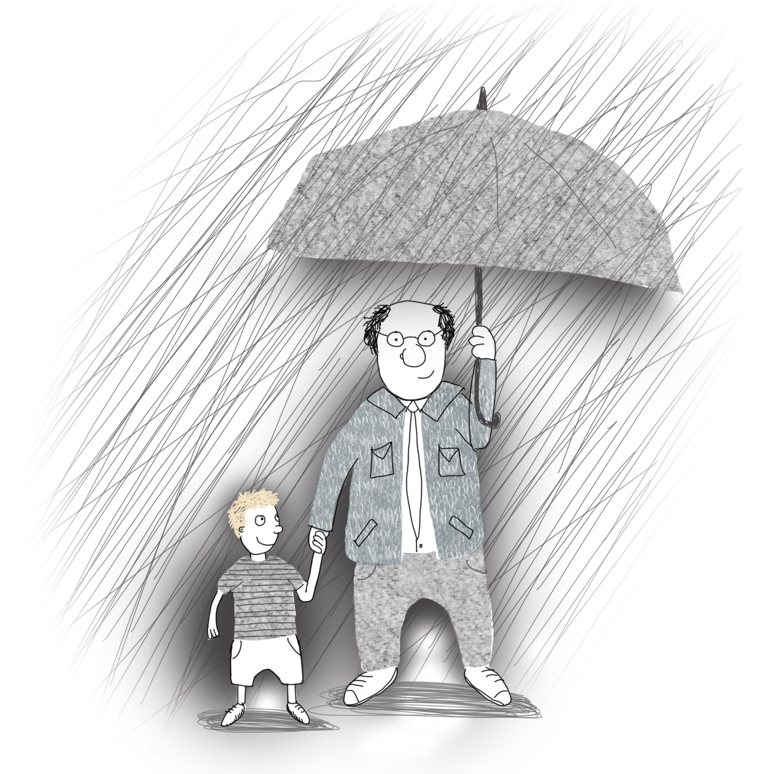

Who’s your Grandad Ken?
Or Nana, Nanny, Grandma, Uncle, Auntie, Mummy, Daddy, child minder…

Name………………….…………………

My_____________________

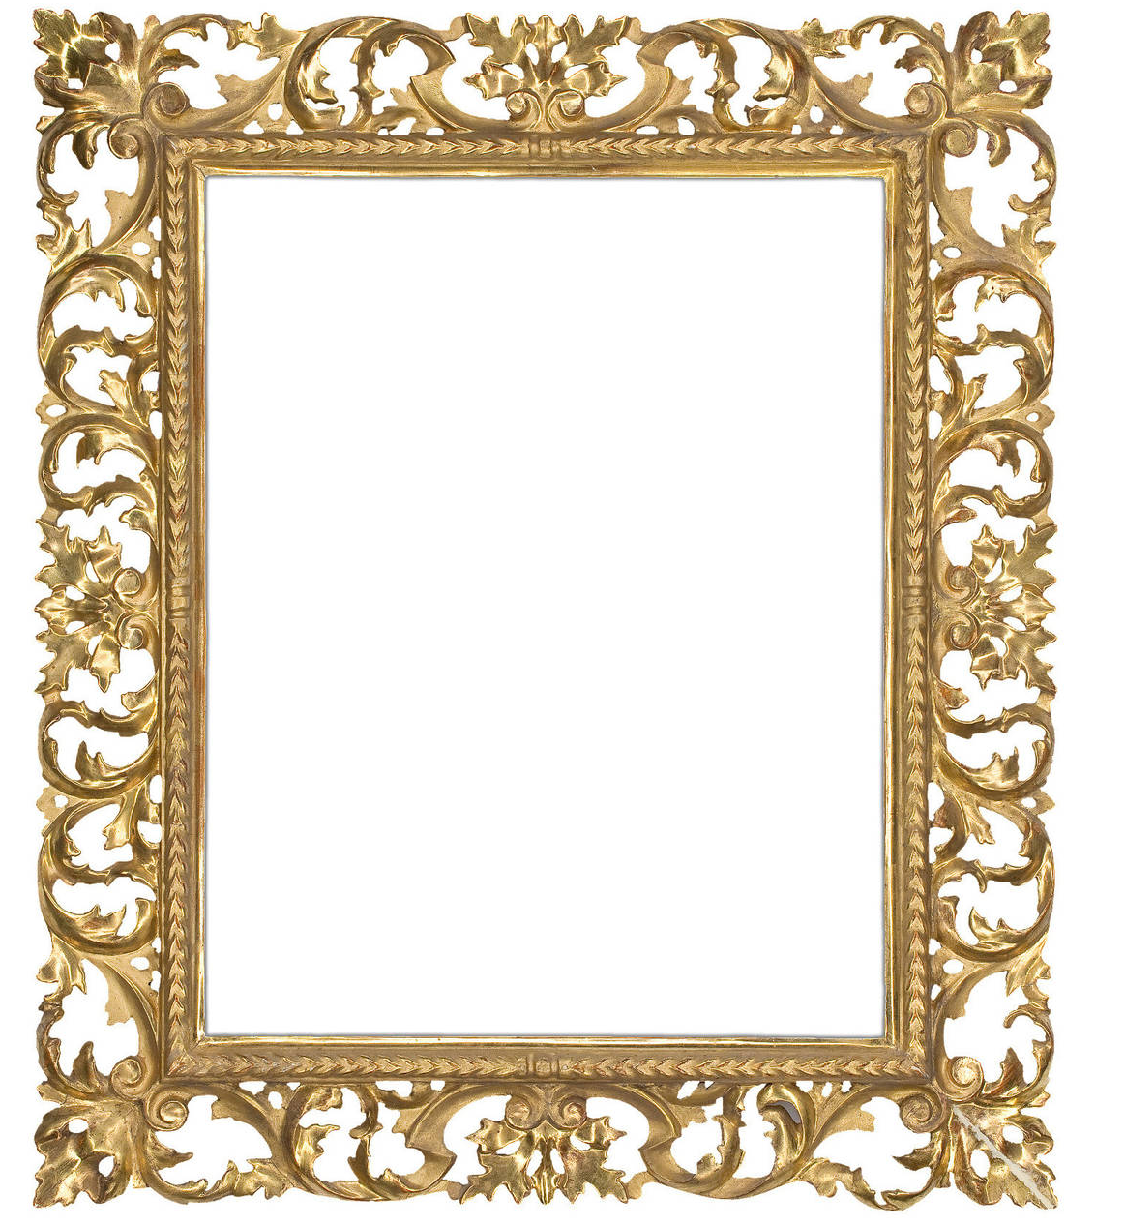

I love you because…

1

2

3

4

5

6

7

Thank you for everything you do!

