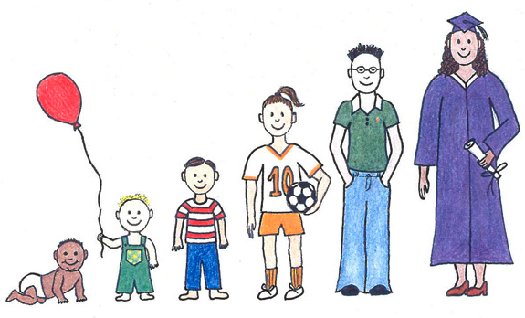
Growing up!

Growing up, growing up, growing up, that’s me!
One day I might be as tall as a tree.

Growing up, growing up, growing up, that’s me!
Ears, mouth, nose and my eyes to see!

When I am older, I’ll drive a car.
I’ll go for miles, near and far.
I might fly and aeroplane in the sky.
I’ll float like a bird, really high!

Growing up…

When I am older I’ll ride my bike.
I’ll pedal for miles, I’ll go on a hike.
I might drive a train to London town,
On silver tracks, up and down!

Growing up…

Especially written for Spinney Nursery, Widnes, Cheshire
© Paul Delaney www.pauldelaneypoetry.co.uk

Friday 11th May 2018

