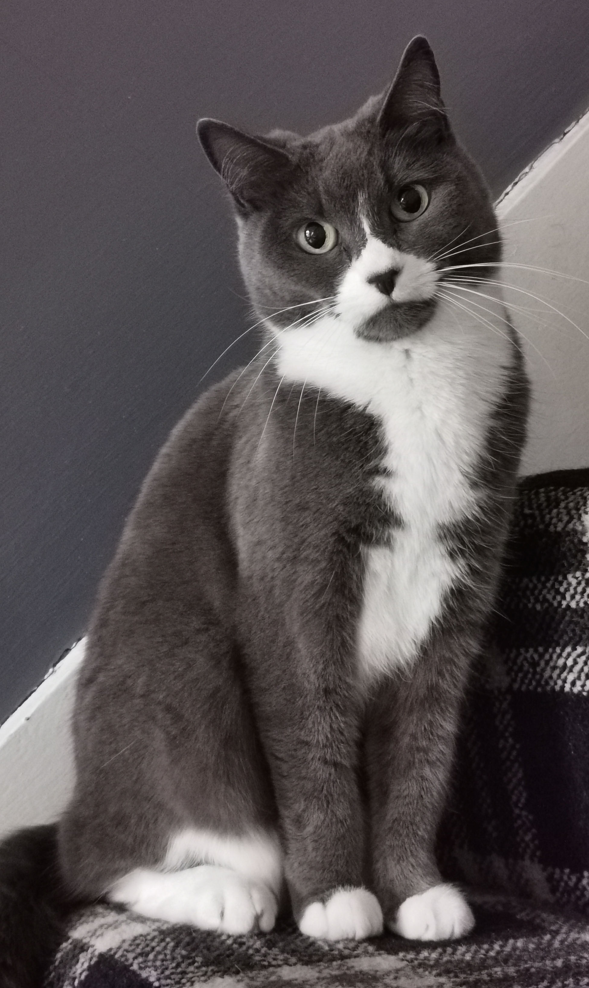
My mysterious moggy!

Where does my cat go
every single night?
For hours and hours,
he’s out of my sight.

His fur is black
and he’s difficult to see.
So as midnight strikes,
where on earth could he be?

I often wonder,
is he a witch’s cat?
Her secret pet,
like a vampire bat?

Is he allowed
a broomstick ride?
Twisting and turning,
hover and glide.

Has he mixed
her potions and spells?
Stirring her cauldron,
bubbling smells.

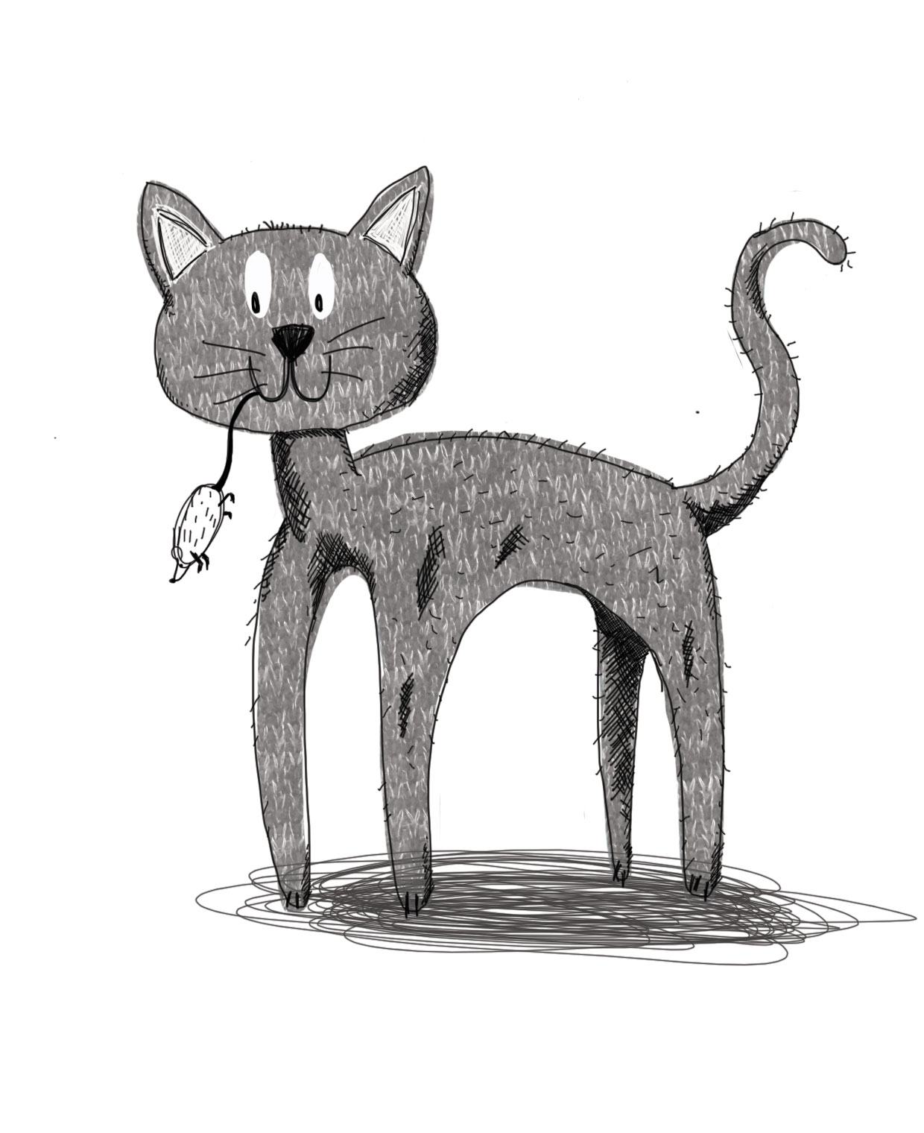

Perhaps he wanders
for miles on Halloween?
Watching ‘trick or treaters’,
without being seen.

Every morning,
he creeps into my house.
And sometimes he’s carrying
a little dead mouse.

But I’ll never know
what his eyes have seen,
his night-time haunts,
the places he has been.

These are his secrets,
locked into his head,
like my secret money box,
hiding under my bed.
(Oh dear, I’ve told you where it is now…)

© Paul Delaney 2016
(From Hedgehogs 1 Big trucks 0)
www.pauldelaneypoetry.co.uk

