Miss, there’s a bee in the classroom!
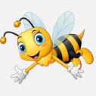
Miss, Miss, there’s a bee in the classroom.
What should I do?
It’s flying around - ‘buzz, buzz, buzz!’
What should I do?

‘Ignore it and get on with your work.
It’s much more scared of you!’

Miss, Miss, there’s a tiger in the classroom.
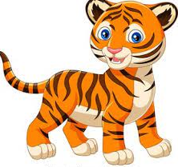
What should I do?
It’s scaring Charlotte – roar, roar, roar!’
What should I do?

‘Ignore it and get on with your work!
It’s much more scared of you!

Miss, Miss, there’s a snake in the classroom.
What should I do?
It’s under my desk –hiss, hiss, hiss!’
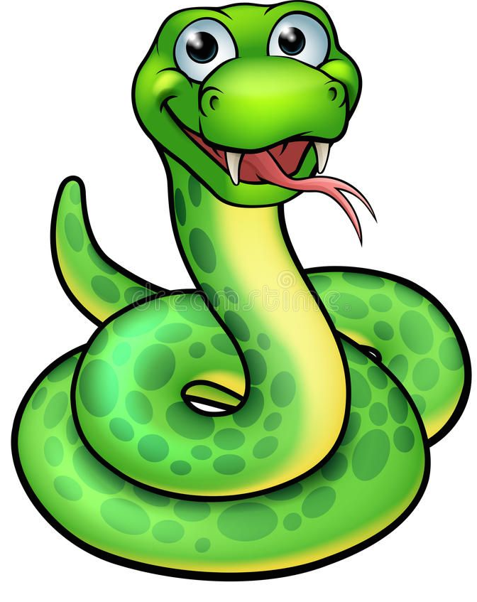
What should I do?

‘Ignore it and get on with your work!
It’s much more scared of you!

Miss, Miss, there’s a seagull in the classroom,
What should I do?
It’s stealing sweets– squeal, squeal, squeal!’
What should I do?

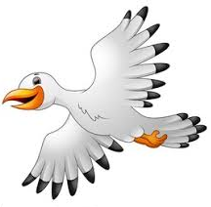
‘Ignore it and get on with your work!
It’s much more scared of you!

Miss, Miss, there’s a spider in the classroom,
What should I do?
It’s big and hairy and it’s climbing up the wall!

What should I do?

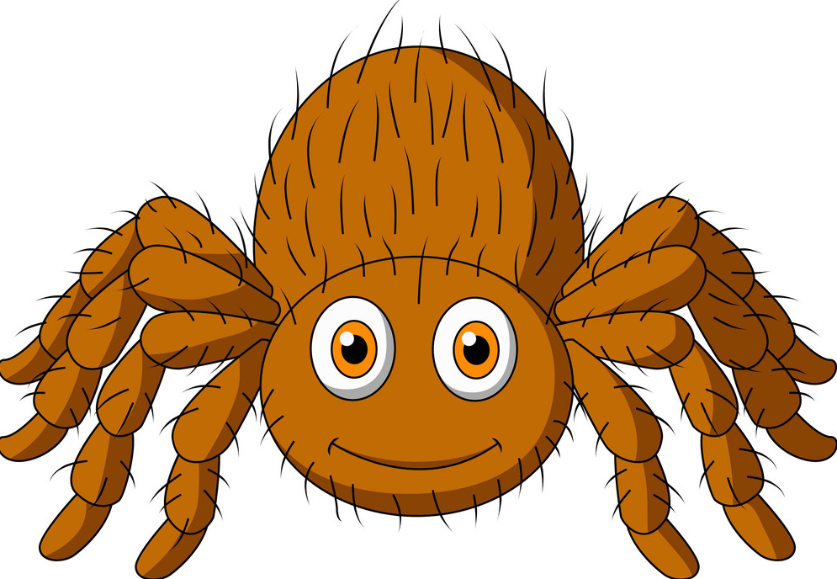
‘Ignore it and get on with your -
What did you say?
A spider, Miss!
Arrgghh!
She’s run off everyone – let’s do what we want!

Halloween 2022 © Paul Delaney

