Your country needs YOU!

‘Your country needs you!’ said the poster.

Just a piece of cardboard hanging on a wall.

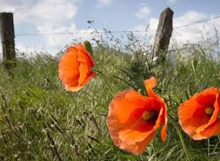
Harry Malone marched past with his friends.

The long, and the short and the tall.

‘Shall we join up and fight for our King?’

asked Harry, to his patriotic pals.

‘If we can wear soldiers’ uniforms,

we’ll be chased around by gals.’

One by one, they scrawled their names,

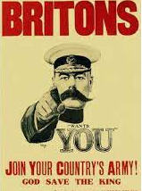
signing their lives away.

Ink flowed through that golden nib,

on that fateful, life changing day.

The pals did train, at Salisbury plain,

over downs and English moors.

Battered by biting winds and rains

and Sergeant Majors’ roars.

Harry did meet a beautiful girl.

His uniform did the trick.

A striking lass called Charlotte Brown,

with long, blonde hair so thick.

‘Marry me please, when you come back home,’

said Charlotte, stealing a kiss.

‘Of course I will,’ said her handsome beloved.

‘My heart, well it bursts with bliss.’
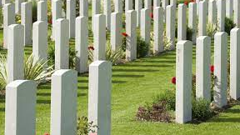

She handed her lover a lock of hair,

encased in a golden charm.

‘Tuck me away in your pocket,’ she said.

‘I will keep you away from harm.’

Weeks passed by and Harry and pals

sailed on a boat to France.

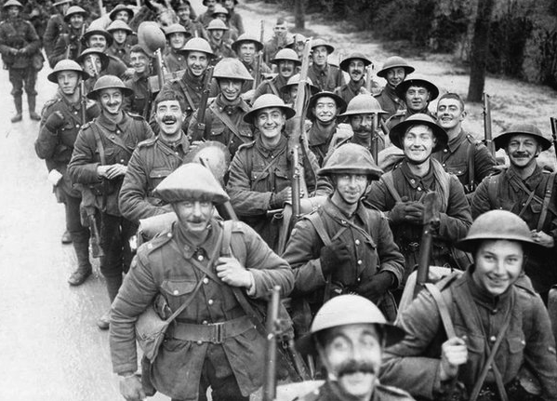
His fiancée’s voice and stunning face

performed a cinema dance.

Harry waited in his muddy trench

for his Captain’s whistle to blow.

‘Fix your bayonets!’ a voice cried out.

‘Fritz deserves a show!’

A piercing pitch punched the air -

a shrill but innocent sound.

And Harry’s battalion went ‘over the top’

by their generals’ orders bound.

Harry and pals formed a line,

advancing through the mud.
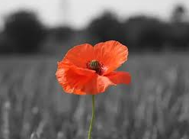

Machine guns rattled and shrapnel flew.

And the earth was bathed in blood.

Harry clutched his golden charm,

housing his sweetheart’s hair;

as he marched towards those Maxim guns

and into the devil’s lair.

Three hot bullets strayed and sizzled

pounding Harry’s chest.

And a soldier died for England

with his pals, who were the best.

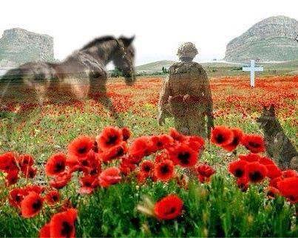
Charlotte’s hair is buried now,

deep under a farmer’s field.

Safely hidden in her lover’s pocket

but one day the earth shall yield.

Private Malone will be found one day,

along with his lover’s charm.

Still together in that blood soaked field

on a peaceful Belgian farm.

© 2016 Paul Delaney,

from ‘My favourite trainers’

www.pauldelaneypoetry.co.uk

Johnny Johnson’s lone Spitfire
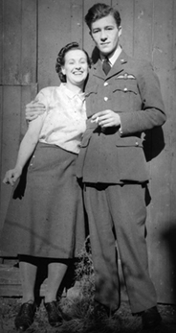
On the bottom of the English Channel;
lies a rusting, wrecked Spitfire.
Squadron leader Johnny Johnson’s
still strapped in its cockpit’s seat.
A handsome chap in those halcyon days,
a renowned and excellent flyer.
Brought down by the guns of a German ace,
a dashing, formidable feat.

Still tucked inside Johnny’s pocket,
below his pilot’s wings,
is an old, damp photograph,
of his fiancée, Charlotte Wright.
A blushing and beautiful English rose.
Oh the pleasures true love brings!
But Charlotte’s heart was broken forever,
on that cruel, summer’s night.

On the bottom of the English Channel,
lies a mangled Messerschmitt.
Oberleutnant Erich Hauptmann’s
still strapped in its cockpit’s seat.
A brave warrior, tall and blonde,
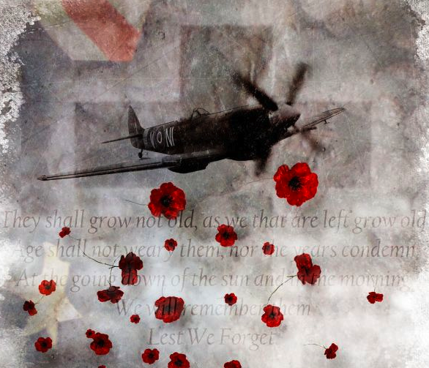
who possessed an inventive wit.
Brought down by the guns of an English ace,
an untimely, cruel exit.

Still tucked inside Erich’s pocket,
sat below his eagle’s wings,
is an old, damp photograph,
of his fiancée, Lara Faust.
Childhood sweethearts, hopelessly in love,
two sweet and innocent things.
But Lara’s heart was broken forever,
on the night of that aerial jaust.

© 2016 Paul Delaney (Poem from ‘My favourite trainers!’ published Sept 2016)

www.pauldelaneypoetry.co.uk

Dearest Lauren

My dearest Lauren,
It’s ‘Zero hour’ for me in about an hour’s time,
so I’m scribbling you a quick poem!
Alas, my love!
If our eyes shall never gaze into each other’s once more, then please never forget me.
For if my name’s on a bullet,
I can promise you only this:

The last thing I’ll see is your face.
The last thing I’ll touch is your skin.
The last thing I’ll smell is your hair.
The last thing I’ll hear is your voice.
The last thing I’ll taste is your kiss.
For a bullet can never steal my dreams away
and extinguish my love for you. Never…

Captain Frederick James Tompkins Somme, July 1916

Frederick’s and Lauren’s spirits crossed paths again, several years ago.
They were married last year, in a beautiful village church.
But in that same, old English church, to the right of the organ,
you’ll find a brass plaque and a framed set of war medals.
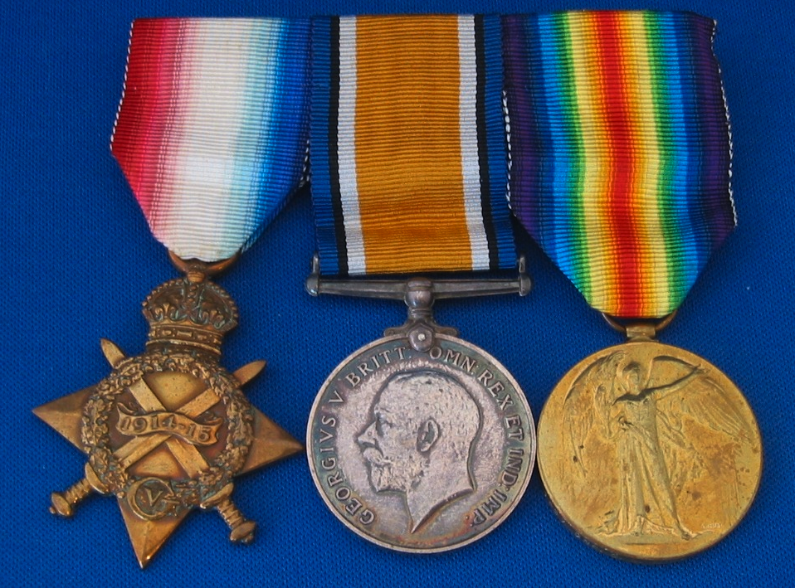
This is what the plaque reads -
‘Dedicated to our precious son,
Captain Frederick James Tompkins,
who’ll forever remain in our hearts.
Died fighting for England’s freedom,
at the first battle of the Somme July 1916.’
Interesting, isn’t it?

© 2012 Paul Delaney (Poem from ‘I’m fed up!’)
www.pauldelaneypoetry.co.uk

