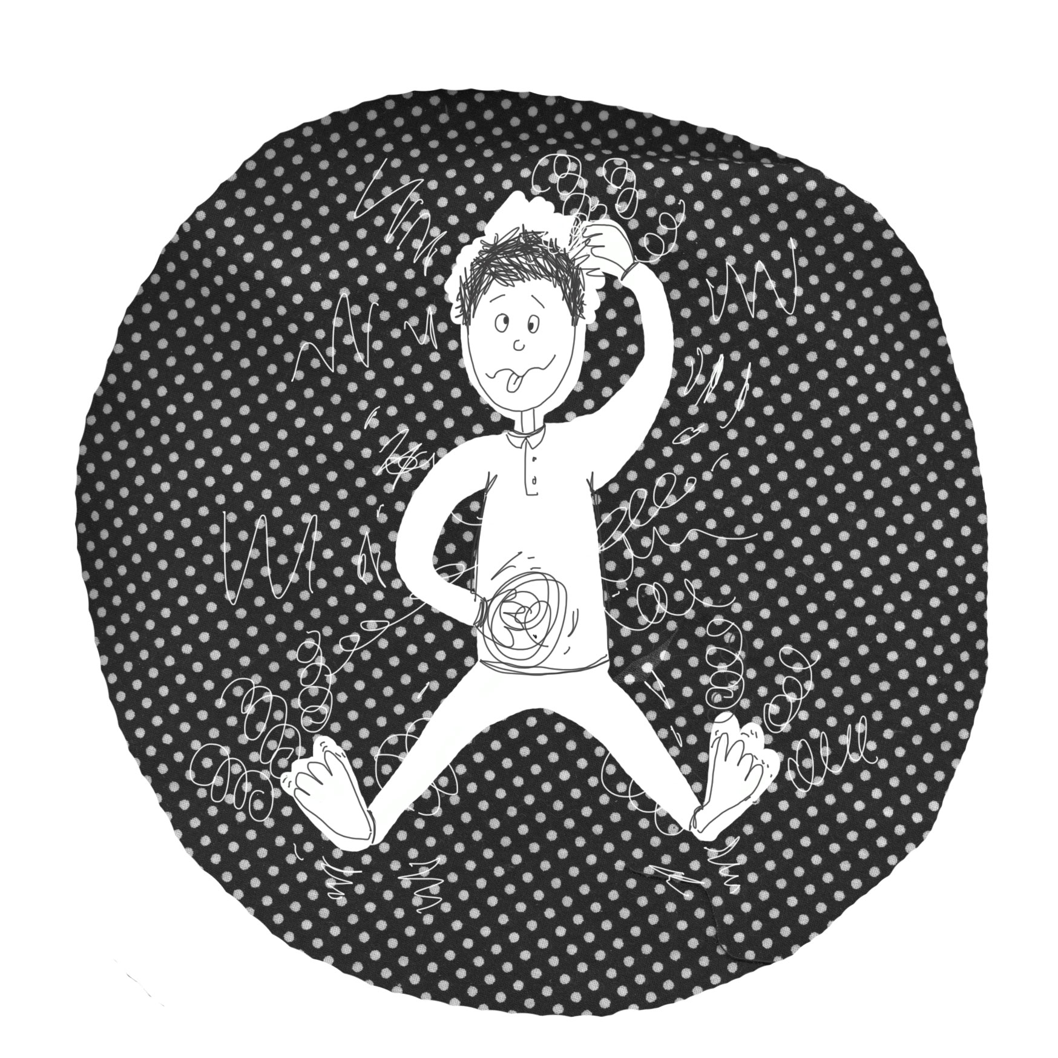
I can wiggle my toes.
Can you?

I can wiggle my toes and stretch my arms.
Can you?

I can wiggle my toes, stretch my arms
and pull a funny face. Can you?

I can wiggle my toes, stretch my arms,
pull a funny face and dance my legs.
All at the same time! Can you?

I can wiggle my toes, stretch my arms,
pull a funny face, dance my legs
and move my head around.
All at the same time! Can you?

I can wiggle my toes, stretch my arms,
pull a funny face, dance my legs,
move my head around
and bend my body like a banana.
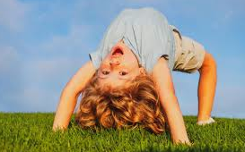
All at the same time! Can you?

I can wiggle my toes, stretch my arms,
pull a funny face, dance my legs,
move my head around,
bend my body like a banana
and scratch my head with my right hand.
All at the same time! Can you?

I can wiggle my toes, stretch my arms,
pull a funny face, dance my legs,
move my head around,
bend my body like a banana,
scratch my head with my right hand
and make circles on my tummy with my left hand.
All at the same time! Can you?

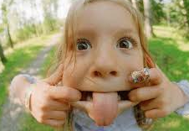
I can wiggle my toes, stretch my arms,
pull a funny face, dance my legs,
move my head around,
bend my body like a banana,
scratch my head with my right hand
and make circles on my tummy with my left hand
And make the loudest, silliest noise in the whole wide world! .
All at the same time! Can you?

If you can, you’re FANTASTIC! Because I can’t!

Because I can’t!

© Paul Delaney 2016
www.pauldelaneypoetry.co.uk

