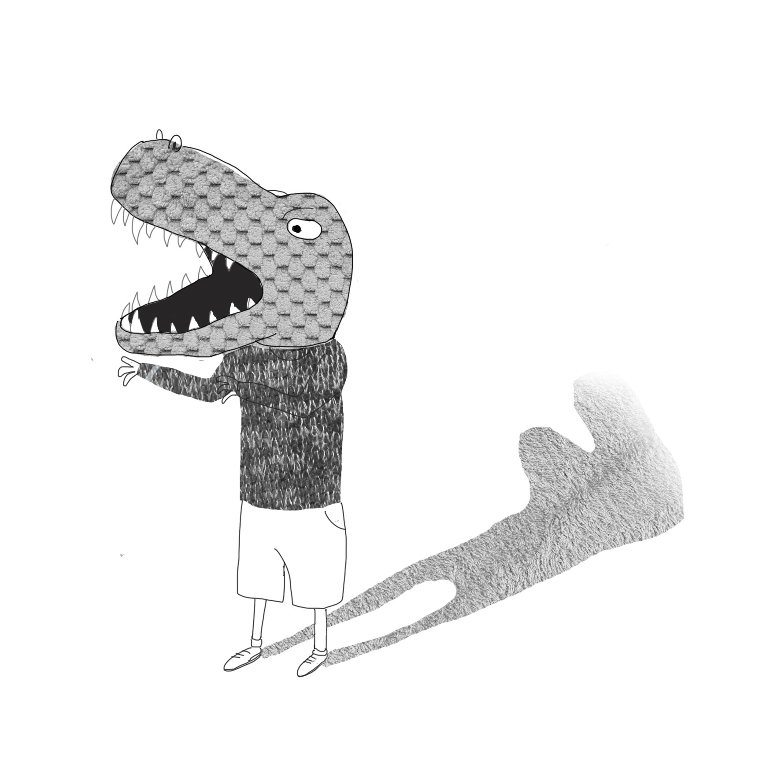
Just pretend!
Pretend you’re a dinosaur!
Rah! Rah! Rah!
Stomp around the hall!
Rah! Rah! Rah!
Reach for the sky!
Rah! Rah! Rah!
Strong and tall!
Rah! Rah! Rah!

Pretend you’re a baby!
Blah! Blah! Blah!
Cry for your mummy!
Blah! Blah! Blah!
Bang your spoon!
Blah! Blah! Blah!
Hungry tummy!
Blah! Blah! Blah!

Pretend you’re a fire engine!
Wah! Wah! Wah!
Drive to a fire!
Wah! Wah! Wah!
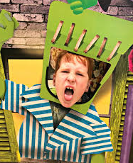
Climb up ladders!
Wah! Wah! Wah!
Higher and higher!
Wah! Wah! Wah!

Pretend you’re your mum!

Pretend you’re your dad!
Pretend you’re happy!
Pretend you’re sad!

Pretend you’re a monster!
Pretend you’re a tree!
Fall on the floor and
Poem from ‘Hedgehogs 1 Big trucks 0

© 2015 Paul Delaney

www.pauldelaneypoetry.co.uk
pretend to go asleep!

