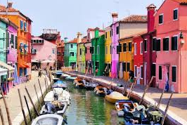
Rainbow colours

Red is a juicy tomato,
yearning to be picked.

Orange is an ice-cold lolly ice,
wanting to be licked.
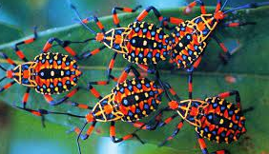
Yellow is a bowl of custard,
coating an apple pie.

Green is an ancient mountain,
stretching across the sky.

Blue is the colour of Everton,
Chelsea and Manchester City.
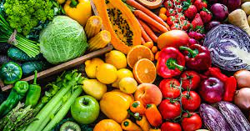
Indigo is a strange one,
a symbol of sorrow and pity.

Violet is a rare wild flower,
it’s also a beautiful name.

It’s sometimes the colour of toilet roll,
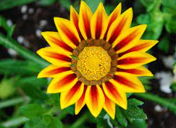
and that’s a terrible shame!

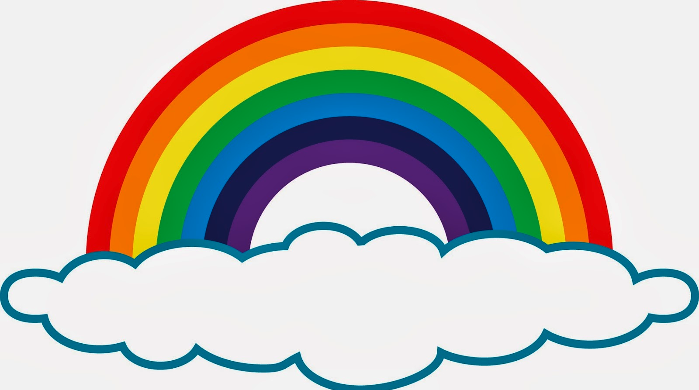 © Paul Delaney 2015
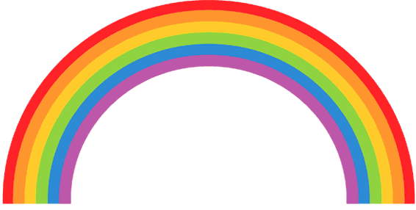
Rainbow colours

Name

Red

Orange

Yellow

Green

Blue

Indigo

Violet

