Reach for the sky!

Hands up high, reach for the sky!
Let’s pretend to fly.

The wind on my face – Space rocket race!
Silver stars shoot by.

Wouldn’t it be great to fly like a bird
or stand in the basket of a hot air balloon.

Wouldn’t it be great to sit on a star
and fly a million miles up to the moon?

Hands up high…

Wouldn’t it be great to pilot a jet
or book a rocket ship to Mars.

Wouldn’t it be great to travel the earth,
in futuristic floating cars!

Paul Delaney © 2016
www.pauldelaneypoetry.co.uk
Especially written to celebrate the opening of:
St Thomas of Canterbury’s Catholic Primary School’s (St Helens)
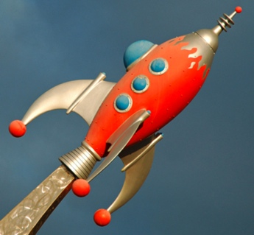
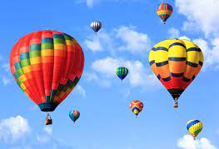
Reading shack – My FIRST ever teaching practice school!

