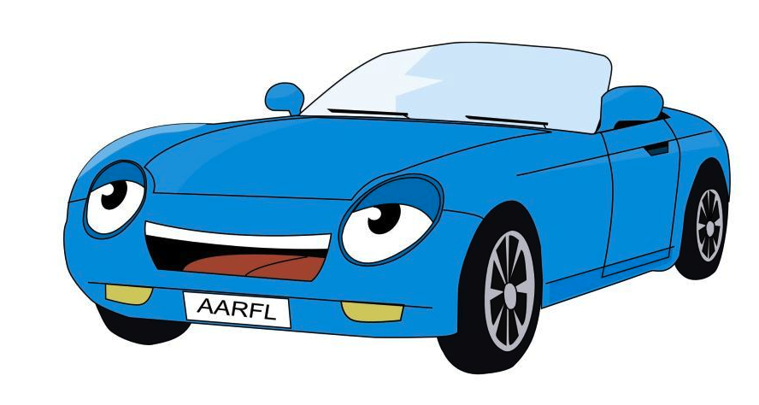
Things to do!

I’m driving my car up this hill. (x3)
So I have something to do.

I’m riding my bike down this road.
So I have something to do.

Things to do, old and new.
Sing and dance and shout.
We’ll play all day, just you and me
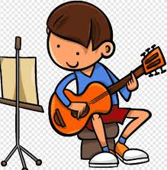
until the stars come out!

I’m running my race around this field.
So I have something to do.

I’m walking my doggy, in the woods.
So I have something to do.

Things to do, old and new.
Sing and dance and shout.
We’ll play all day, just you and me
until the stars come out!

I’m playing my guitar, in my bedroom.
So that I have something to do.

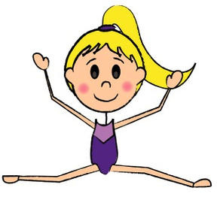
I’m doing gymnastics in the hall.
So that I have something to do.

Things to do, old and new.
Sing and dance and shout.
We’ll play all day, just you and me
until the stars come out!

Written for: New School, Rome, Italy

© Paul Delaney
Thursday 25th January 2018

www.pauldelaneypoetry.co.uk

