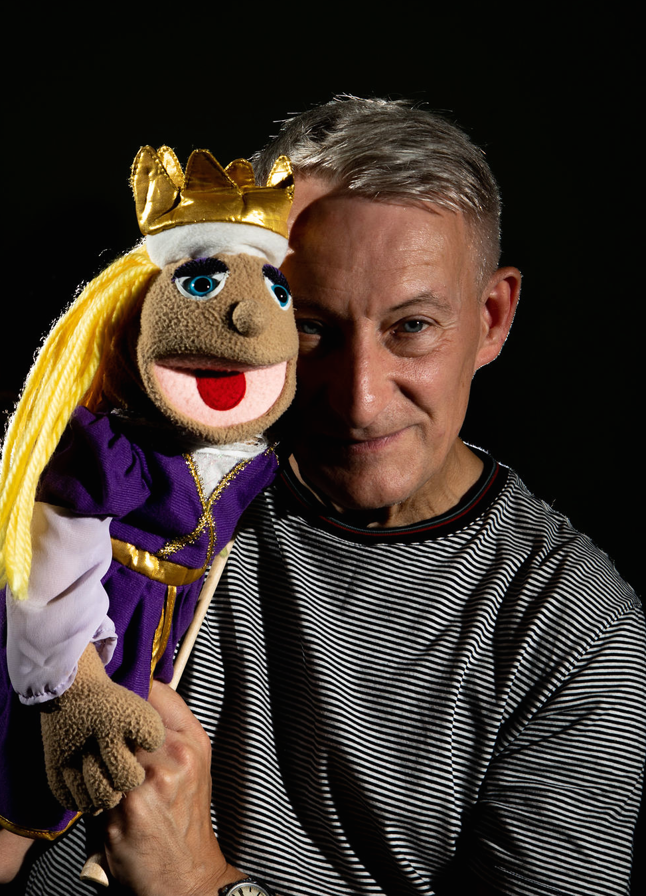

Children’s author and performance poet,
Paul Delaney
is visiting
Cornybobbleton CE Primary School
on…
Monday 3rd October 2022

Chance to order
Paul’s signed books!

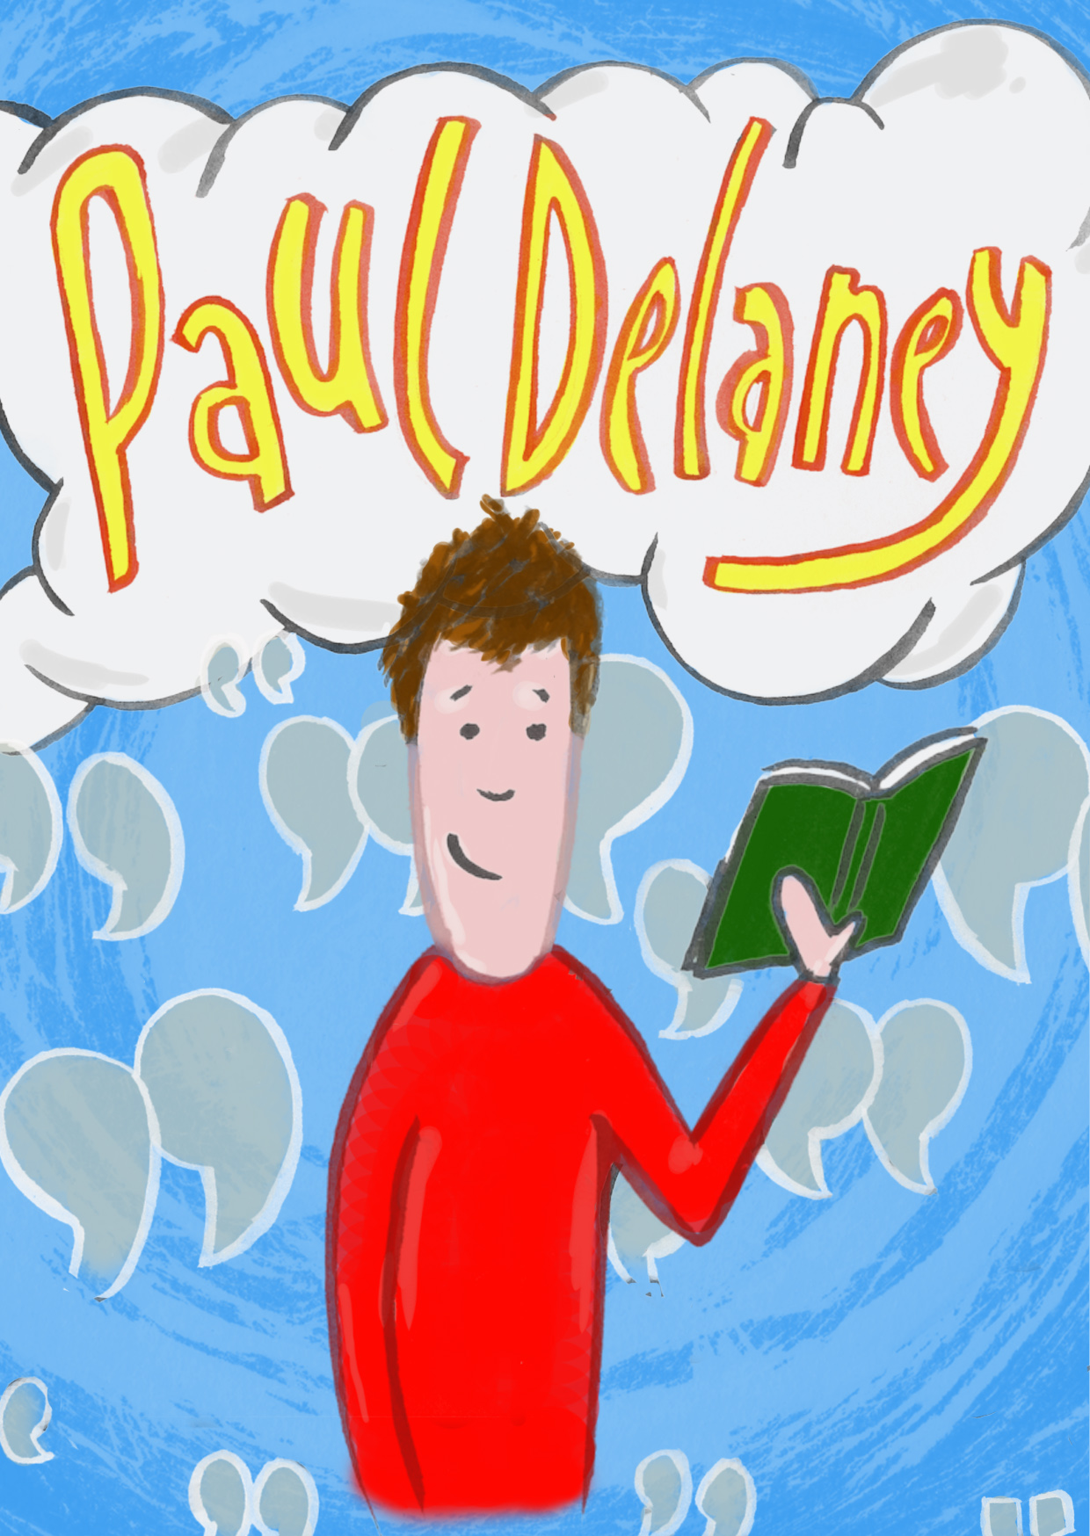
www.pauldelaneypoetry.co.uk

