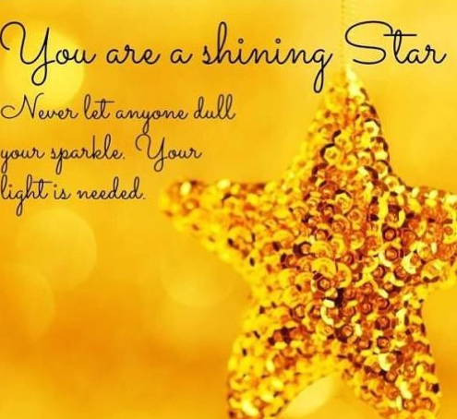

Shine, shine, shine!

Shine, shine, shine like an everlasting star.
Shine, shine, shine, God has carved me on his hand.
Shine, shine, shine like a diamond in the sky!
God is always near – he’s the footprints in the sand.

My spirit is bright, like an everlasting flame.
Jesus says I’m special and he even knows my name.
He fills me with love and he cares for me.
He will hold my hand eternally.

My spirit is strong, like a golden eagle’s wings.
God lifts me up and my soul begins to sing!
He fills me with strength, for the world to see.
He will hold my hand eternally.

My spirit is power, like a wondrous waterfall.
God lives within me and I hear his guiding call.
He fills me with fire and energy.
He will hold my hand eternally.

© Paul Delaney November 24th 2021 www.pauldelaneypoetry.co.uk

Premiered at St Wilfrid’s CE Primary School, Grappenhall, on Thursday 25th November 2021

