The Sock Monster

It’s not in my drawer.
It’s not in my wardrobe.
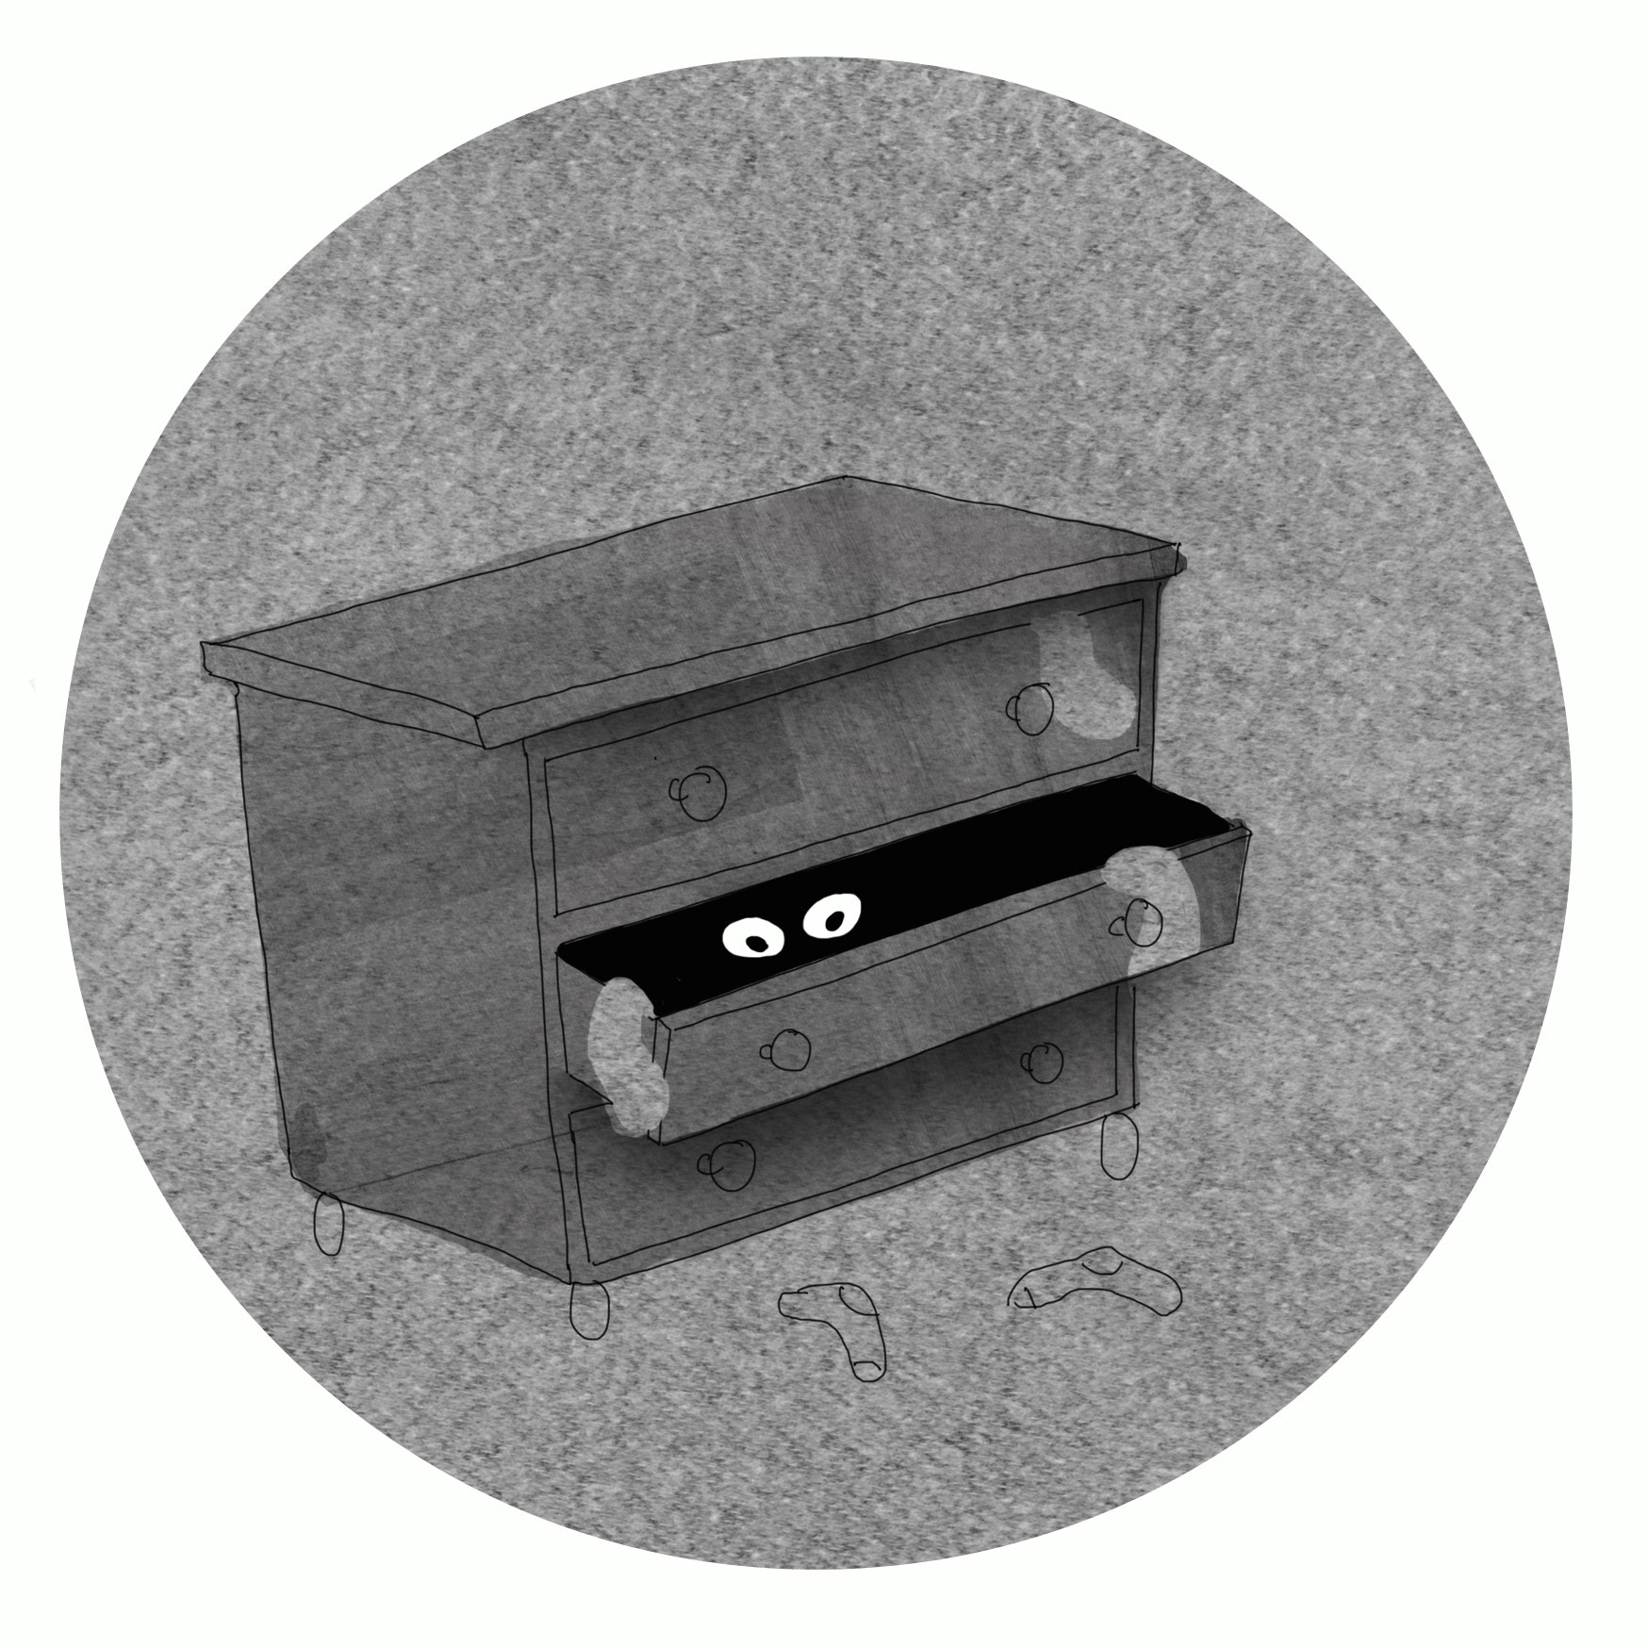
ONE of my socks, white and red.
It’s not in the basket.
It’s not on the floor.
It’s definitely not under my bed.

It’s not in the washer.
t’s not in the drier.
It’s not on my bedroom floor.
It’s not in my pocket.
It’s not in my school bag.
It’s definitely no more.

The sock monster’s ate it.
He’s greedy and fat.
He’s taking a hungry bite.
He’s hiding in darkness.
He’s lurking in shadows.
An expert at ‘out of sight’.

He likes multi-colours
and different materials.
His favourites are football socks.
He creeps into rooms
in the middle of the night,
a sly and cunning fox.

He roots through my drawers
and opens my wardrobe,
searching for precious prey.
One sock he steals, from a fancied pair.
Before he slips away.

Into the night he disappears.
He’s vanished in a tryst.
And I wake up in the morning,
searching for my socks missed… © Paul Delaney 2015

www.pauldelaneypoetry.co.uk

