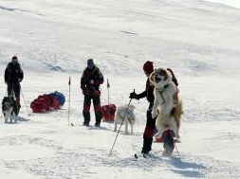
Follow my footsteps –
AN EXPLORER poem!

Follow my footsteps - discover different lands!
Blankets of snow and hot desert sands!
Dangerous places, excitement high and low.
Magical creatures - fast and slow.

Look through my telescope – what can you see?
An Arctic fox is following me.
An iceberg stands as tall as a tower
and a Beluga Whale’s having a shower!

Look through my telescope – what can you see?
A polar bear is following me!
An Emperor penguin walks with a waddle
and an Elephant seal’s having a paddle!

Follow my footsteps - discover different lands!
Blankets of snow and hot desert sands!
Dangerous places, excitement high and low.
Magical creatures - fast and slow.

Look through my telescope – what can you see?
An Arctic wolf is following me.
A snowy owl’s searching for prey
and a baby moose is having a play.

Look through my telescope – what can you see?
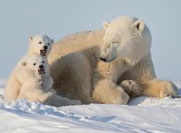
An Arctic hare is following me.
A Reindeer wanders across the snow
and Humpback whale’s having a blow!

Follow my footsteps - discover different lands!
Blankets of snow and hot desert sands!
Dangerous places, excitement high and low.
Magical creatures - fast and slow.

Written for Stubbings Infant School, Hebden Bridge, West Yorkshire January 2023

© Paul Delaney 2023 www.pauldelaneypoetry.co.uk

