A definition of clauses

Independent clause (Main clause):

I like Aimee’s friend.

Dependent clause (Subordinate clause)

I like Aimee’s friend even though she’s annoying!

Relative clause

I like Aimee’s friend, who is called Sadie, even though she is annoying!

Santa Claus

A big man who often goes by the name of ‘Father Christmas’ and works one day a year.

Cat’s clause

Curved and pointed horny nails on each digit of the feet of a cat. Or is it Cat’s claws?

A load of words

You can unload a wardrobe,
an IKEA flat pack.
You can upload a photograph,
onto your Mac.

You can offload a rugby ball,
whilst a player’s on your back.
You can download ‘Thriller’,
Michael Jackson’s classic track.

You can overload your mind
but you’ll probably crack.
As an invisible sledgehammer
strikes your head – whack!

You can expload a stick of dynamite
but it’s wrong in a spelling test.
I’ve exhausted all the ‘load’ words,
so I’m going for a rest!=
Mrs Weller’s Radley handbag

(A nonsense apostrophe story – From ‘Get lost!’

Isabella grabbed Olivia’s hair.
She got into serious trouble for it!

Olivia hid Harry’s bag
under fallen coats in the cloakroom.

Harry’s still searching…

But Mrs Weller’s ‘Radley’ handbag disappeared too, along with all its precious contents!

Mrs Weller marched into the teachers’ staffroom.
What on earth goes in in that place? Who knows?

The teachers changed, imitating miserable monsters.
They cancelled the children’s afternoon playtime until Miss’ precious, designer handbag was found. (Oh dear, who’s responsible this time?)

Mrs Weller screamed in her classroom,
huge veins popping out of her neck.

‘I know it’s one of you lot, probably Heidi Glum winding me up, so if my handbag doesn’t turn up by the end of today, Heidi’s parents will definitely be informed!’

‘But it wasn’t me, Miss,’ Heidi cried, banging a hard fist onto Sara’s desk, t
ears pricking her eyes.

‘Well it wasn’t me!’ Sara snapped, rolling her eyes in her usual fashion, landing like lazer beams onto Heidi’s ashen face. ‘Why look at me?’

‘Somebody’s stolen my Radley handbag!’ Mrs Weller cried, her eyes popping out of their sockets like huge golf balls.

‘And if I don’t find it before home-time, I’ll be texting a police officer’s iPhone as my son in law is a detective. They don’t call him Sherlock Holmes’ student for nothing!’

Everybody squabbled.
Mouths gaped open. Fists almost flew.

Mrs Weller blew her whistle,
a small, silver thing but so powerful all the same.

‘Referees’ whistles are the best,’ she said,
folding her long arms. ‘
Cuts through the air like a knife through butter!

Anyway, afternoon playtime is not cancelled any more – it’s now ON!
Hooray!’

‘Why?’ George asked, casting his eyes over his teacher’s face, deep wrinkles like railway lines etched into her grey skin.

‘I’ve just remembered,’ Mrs Weller remarked,
a wry smile on her face.

‘My handbag is in my car. I left it on the passenger seat this morning! Sorry everybody, especially you, Heidi. No excuse for blaming you!

Anyone for mathematics?
How about fractions – teachers’ favourite!

Then again, 5/4 teachers can’t understand them.

Fortunately, I do!

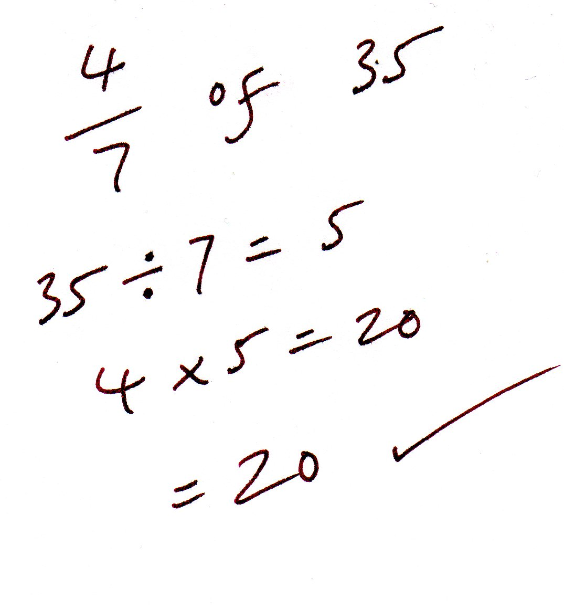
Sometimes…’

Do you know what I am?

(Fronted adverbials poem)

Stealthily, I prowl;
it’s almost the midnight hour.
Nervously, I search for food,
a mouse perhaps, to devour.
Hurriedly, I hide in shadows,
a dog’s around – that’s power!

Do you know what I am?

Loudly, my engines roar,
I wonder where I’ll go?
Excitedly, my cargo sits,
alone, a family in tow.
Rapidly, I cut through the clouds;
I suppose I’ll go with the flow…

Do you know what I am?

Quickly, I rip open my presents,
on yet another year.
Sadly, Grandad’s no longer here,
so I release a tear.
Happily, I think of his angel’s wings,
so now I know he’s near.

Do you know what I am?

Slowly, I slide, along my path,
leaving a slimy trail.
Bravely I plod, painstakingly slow,
in wind, rain and hail.
Surprisingly, I’m sometimes quicker
than a postman’s second-class mail.

Yes, you’ve guessed it and you’re right!

I am a lonely snail!

All poems © Paul Delaney 2018

www.pauldelaneypoetry.co.uk

