Henry Hubble

Henry Hubble was washing the dishes
when a bubble suddenly popped.
A pixie appeared and granted him wishes
and Henry’s jaw just dropped.

‘Whatever you ask for will come true!’
said the pixie, scratching his beard.
‘But once a minute has ticked away,
my magic will disappear.’

Henry wasted precious seconds,
thinking of things to say.
He found his tongue and shouted out,
without a moment’s delay.

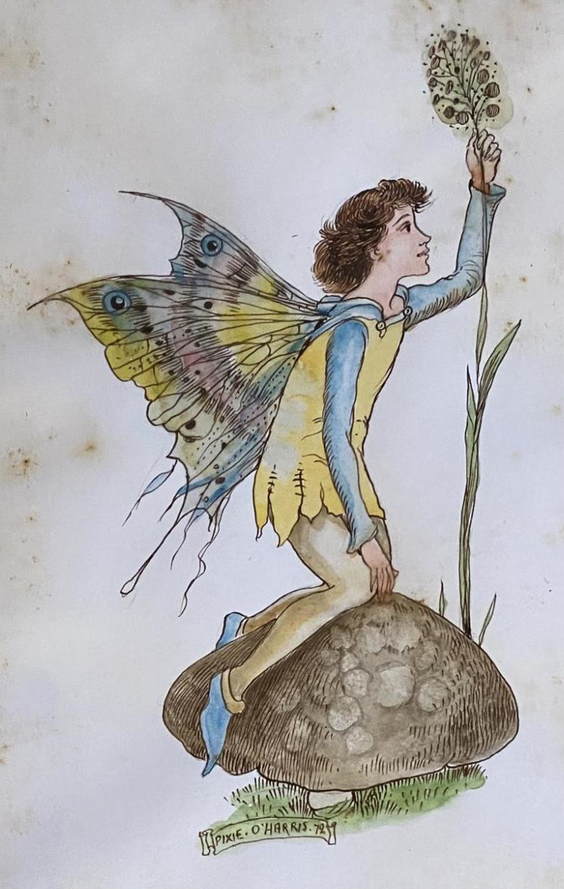
‘A wheelchair for my grandad Bob,
for he can hardly walk
and a miracle cure for my brother Tom,
who finds it hard to talk.

An ‘Aston Martin’ for my mum,
chosen by James Bond
and a lovely house for my dad,
with a garden and a pond.

Two new knees for Auntie Pat,
who struggles around the house
and a Zimmer frame for Uncle Joe,
to help him get about.

A boyfriend for my next door neighbour,
who’s lonely on her own.
And a brand new kennel for my dog Spot,
with an everlasting bone.

And as for me I’d like…’

‘Your time is up!’ the pixie yelled.
‘You’ve used up all your wishes!’
So Henry shrugged his shoulders
and continued washing the dishes.

© 2012 Paul Delaney
Poem from ‘I’m fed up!’

www.pauldelaneypoetry.co.uk

