I wonder…

I wonder what a goldfish thinks about,
swimming in a bowl.
Is he dreaming of a bigger tank
or a long lost family shoal?
Is he waiting for another fish
to share his watery home?
Or is he happy all alone,
the King of his own glass dome?
I wonder…

I wonder what a parrot thinks about,
sitting in a cage?
Is she happy talking and squawking,
a performer on a stage?
Is she dreaming of her jungle,
longing to stretch her wings?
Or is her spirit fading,
forgetting what freedom brings?
I wonder…

I wonder what a dog thinks about,
abandoned by his owner?
Is he feeling rejected,
like a long, lost loner?
Is he enjoying being a stray,
newfound freedom to roam?
Or dreaming of a family
and a warm, loving home?
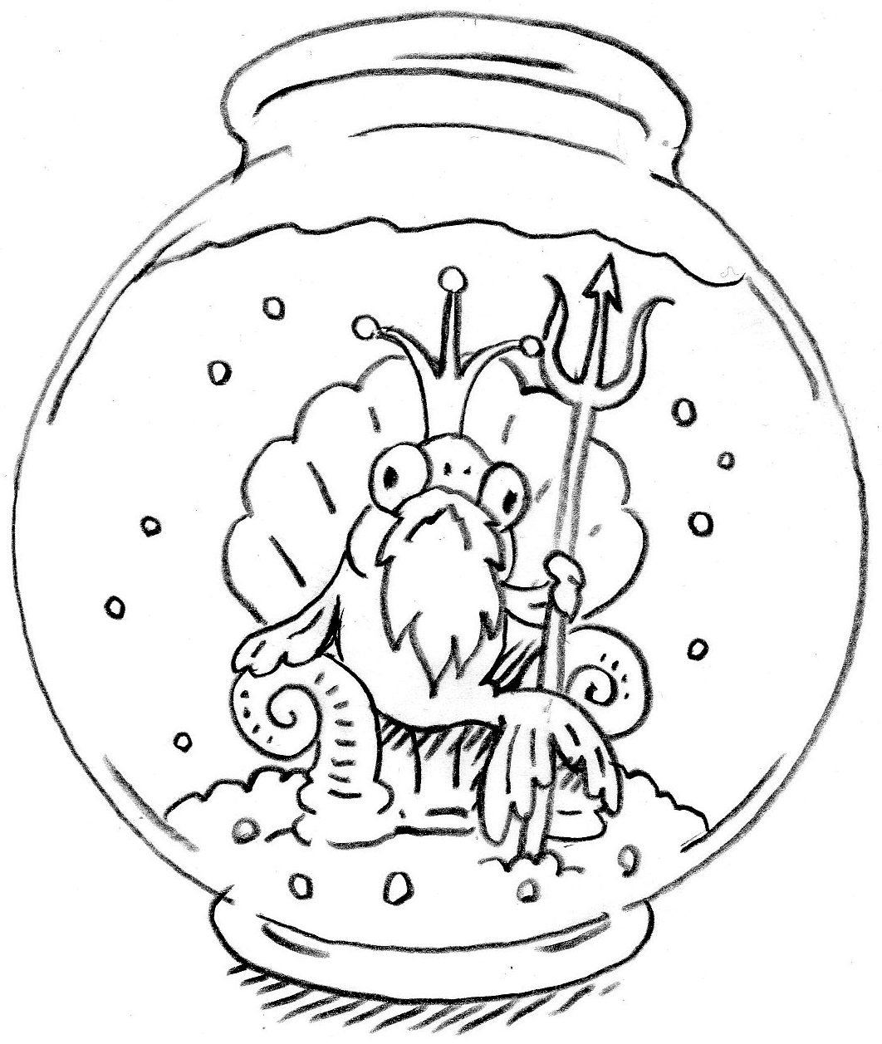
I wonder…

I wonder what a brown bear thinks about,
dancing in the street?
Is he happy on his chain,
skipping to the beat?
Is he dreaming of a mountain,
a forest or a meadow?
Or praying for a future
and a better tomorrow?
I wonder…

I wonder what an orang-utan thinks about,
sitting in his tree?
Is he peering at bulldozers,
just thinking ‘why me?’
Is he dreaming of an invention,
to destroy this machine?
Or worrying about captivity,
for what could that mean?
I wonder…

I wonder what a pig thinks about
on the road to be killed?
Is she imagining bacon and sausages,
salted, smoked and grilled?
Is she hating her farmers,
with a sad, subtle sigh.
Or dreaming of her heaven,
green fields in the sky?
I wonder…

© Paul Delaney 2018
www.pauldelaneypoetry.co.uk
The original of this poem is in ‘I’m fed up!’
This is the new, ‘animal’ version!

