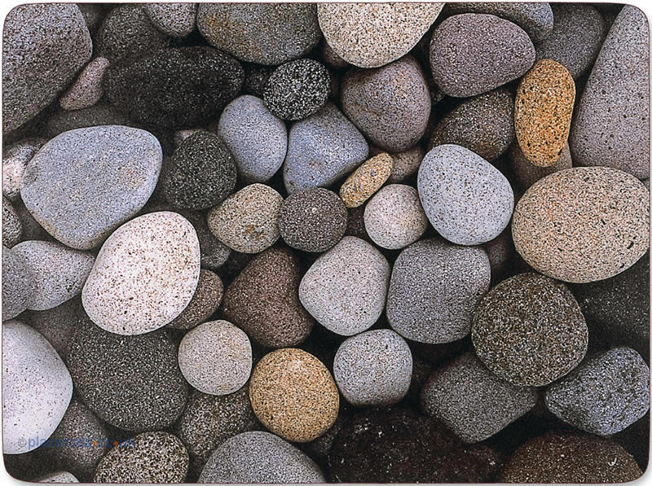  Harry Delaney  19th July 2014 | Your pebble, which has chosen YOU as its guardian and protector, will guide you throughout your life. When you are feeling lonely and afraid, hold your pebble. Strength will suddenly appear. When you are at a crossroads, hold your pebble. The answers you are looking for will mysteriously appear out of the silence. God will whisper to you, from the secret, heavenly realms of the angels. Clouds will disappear  When you are filled with love and happiness, hold your pebble. Give thanks for all the wonderful things appearing in your world. But most of all, remember your time at this school. Give thanks for the people who have crossed your path. Clasp your pebble in your hand. Hold it. Touch it. Feel it. And always remember this: There is only ONE pebble in the world like yours – it’s precious, special and unique. Just like you – so always remember that! And if you forget, hold your pebble – it will remind you of just how SPECIAL you are.

GREAT, INEXPENSIVE IDEA FOR A LEAVERS’ PRESENT

This idea is my own. I’ve used it in Y6 many times. It’s so simple – It can be used in secondary schools too. If you’re after a ‘present’ for your leavers, this is great. Go to a beach, collect different pebbles of similar size for your class. Look for nice ones.
(Don’t buy any of those ‘shiny’ ones from a shop – the natural look is always the best.)

I’ve written all the words on the cards. It’s not from any book – it’s all my own work.

Pile the pebbles up in the middle of the classroom in the last week, just before the children leave. They then ‘choose’ a pebble to take home. I used to laminate the above card and on the back, I’d always scribble a personal message and a head and shoulder cartoon sketch of the pupil, such as:

(All in normal handwriting!)

Rebecca – a fantastic, sporty girl who’s always smiling! You’re such a popular girl and a brilliant netball player too! Go for it in your new school. Success awaits you!! Love, Mr.Delaney…

(You know the type of thing!)

It’s interesting that years and years later, I still bump into children who I’ve taught who tell me they’ve still got their pebble and card in a special place – and it reminds them of our school…

Thanks, PD

www.pauldelaneypoetry.co.uk

