Rebekah’s handkerchief.

A precious kiss, a gentle touch,
snatched in the briefest of moments.
A voice cries out, a high pitched haze,
a dissonant despair.
A lonely tear drops away, soaking up the dust.

And Rebekah clutches her handkerchief,
crimson, without a seam.

A wanton shout, a wicked laugh,
etched in a camera’s lens.
A German shepherd barks for joy,
a symbol of power and struggle.
An old Professor falls to the floor,
draining his empty spirit.

And Rebekah clutches her handkerchief,
crimson, without a seam.
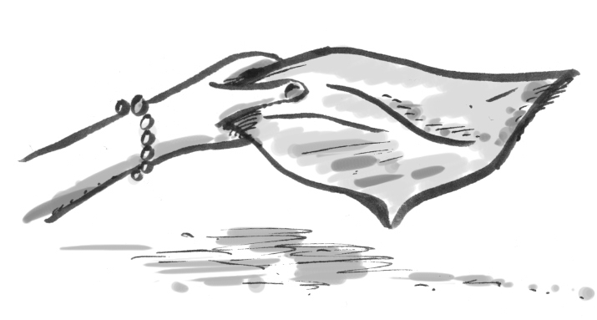

A plume of smoke rises high, searching for a heaven.
A little baby twists her face, longing for a breast.
A hideous soldier cocks his gun, dancing with the devil.

And Rebekah clutches her handkerchief,
crimson, without a seam.

A bewildered child follows his mummy,
shuffling towards death’s door.
A frightened daddy kneels and stares,
praying his useless words.
A broken heart bursts a chamber, crying out a song.

And Rebekah clutches her handkerchief,
crimson, without a seam.
A door is opened.
The innocents push,
bathed in electric light.
A pleasing shout is ringing out.
Love’s pure dove is fluttering.
A shutter opens, a ghastly wind,
strangles a hundred throats.

And Rebekah clutches her handkerchief,
crimson, without a seam.

Time devours sacred seconds,
a whispering wind is tame.
A hardened guard unlocks the door,
brushing off his shame.
Tormented, broken bodies fall,
a terrible, twisted dream.

And a handkerchief lies without an owner,
crimson, without a seam.

© 2012 Paul Delaney
Poem from ‘I’m fed up!’
www.pdelaney.co.uk

