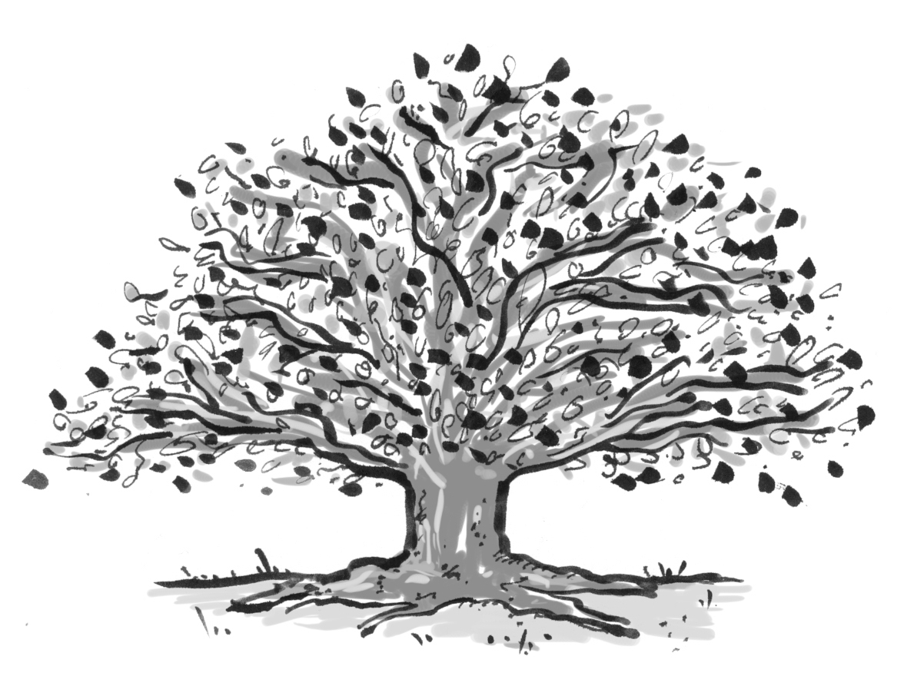
Thank you for…

Thank you for a thick, warm sunbeam, gently caressing my face.
Thank you for a silver star, mysteriously twinkling in space.

Thank you for a floating snowflake, drifting in the sky.
Thank you for a snow capped mountain, stretching up so high.

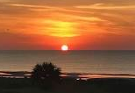
Close your eyes. Draw in a deep, life-giving breath.
And in the silence, give thanks.

Thank you for a colourful flower, swaying quietly in the breeze.
Thank you for its potent perfume, attracting busy bees.

Thank you for a precious raindrop, long awaited by desert sands.
Thank you for a wealth of creatures, unique to different lands.

Close your eyes. Draw in a deep, life-giving breath.
And in the silence, give thanks.

Thank you for the seas and oceans, their secrets cold and deep.
Thank you for the seeds of creation, sowing in order to reap.

Thank you for a carpet of grass, a field of emerald green.
Thank you for heaven and earth and the mystery in between.

Close your eyes. Draw in a deep, life-giving breath.
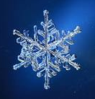
And in the silence, give thanks.

Thank you for a forest of trees, damp jungles and ancient woods.
Thank you for a puddle to stamp in; left by ruthless floods.

Thank you for my spirit’s essence, as I am truly unique.
Thank you for the answers to the secrets that I seek.

Close your eyes. Draw in a deep, life-giving breath.
And in the silence, give thanks.

For if we appreciate all that’s around us, it’s good to be alive…

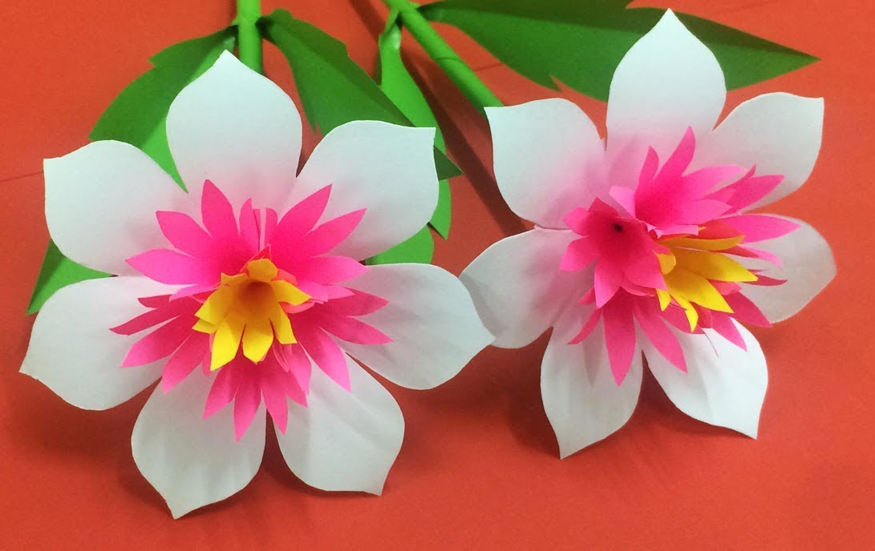

© Paul Delaney 2016

www.pauldelaneypoetry.co.uk

